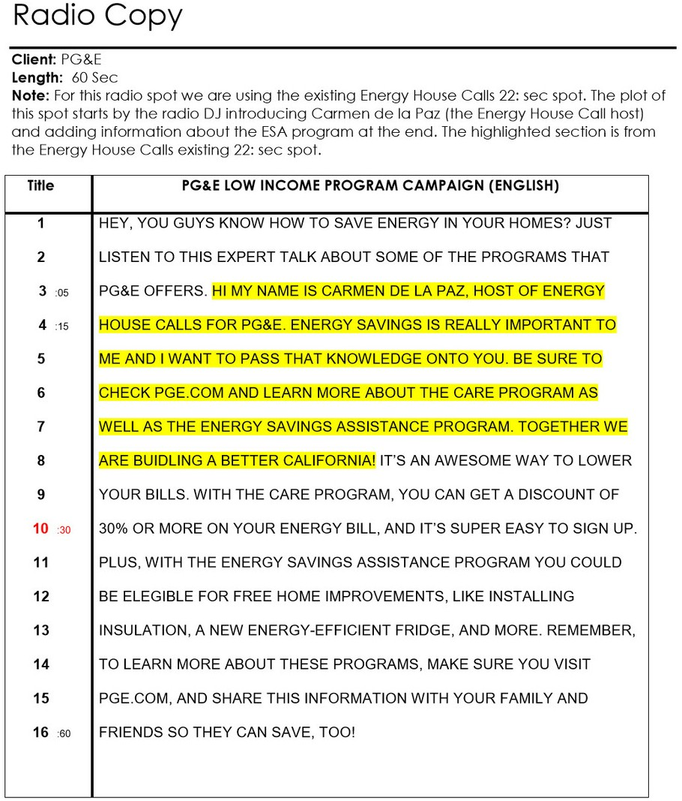
Compliance Packaging Campaign
(Music)
No more sorting meds, waiting in line, or chasing down reﬁlls. _______ Pharmacy oﬀers PakMyMeds compliance packaging. Here’s how it works...
We work directly with your doctors and insurance to save you the time and frustration.
We monitor and sort all of your prescriptions by date and time — organize them into compliance packages so you can pick them up with no wait.
No more requests for reﬁlls and no more sorting.
We do it all for you at Sherrie’s Pharmacy. Call us at 404-­‐777-­‐2112 Compliance packaging at _______Pharmacy. Simply your life.

COMC CLIENT: COMPLIANCE PACKAGING RADIO
LENGTH: 0:30

Phone: 877.797.2332
Email: info@rxsafe.com www.rxsafe.com
2453 Cades Way, Suite A Vista, CA 92081

